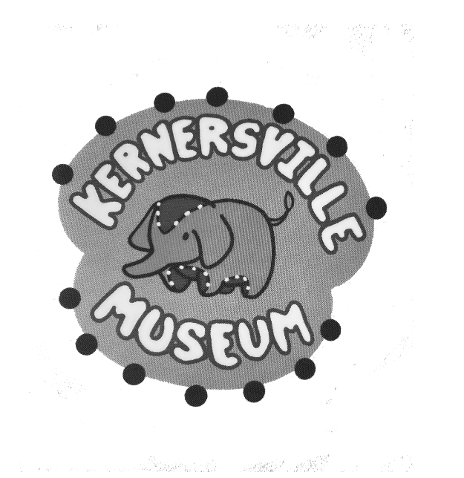**Kernersville**

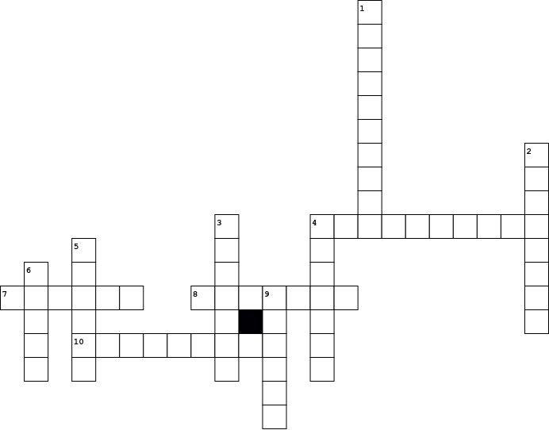

|  |  |  |  |  |  |  |  |  |  |  |  |  |  |  |  |  |  |  |  |  |  |  |  |  |  |  |  |  |
| --- | --- | --- | --- | --- | --- | --- | --- | --- | --- | --- | --- | --- | --- | --- | --- | --- | --- | --- | --- | --- | --- | --- | --- | --- | --- | --- | --- | --- |
| |  |  | | --- | --- | | **Across** | | | **4.** | ate breakfast in town | | **7.** | family that town is named after | | **8.** | how many people made a living | | **10.** | an item of great significance | |  | |  |  | | --- | --- | | **Down** | | | **1.** | Center of town | | **2.** | when you put seeds in the ground | | **3.** | important crop in town | | **4.** | type of one room cabin | | **5.** | name of the mineral springs | | **6.** | where people wait for a train | | **9.** | a place to display artifacts | |