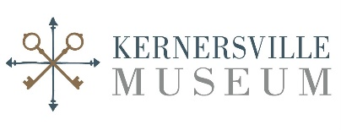
Kernersville Museum
Internship Application

Personal Information
Name: ______________________________________________________________
Last First Middle Initial

Permanent Address: _______________________________________________________
Current Address:__________________________________________________________
Preferred Phone: (_______)_______________
Email: ________________________________________________
Date of Birth: ___________________________

Education
High School: ☐ Freshman☐ Sophomore ☐ Junior ☐ Senior
School Name:_______________________________
College: : ☐ Freshman☐ Sophomore ☐ Junior ☐ Senior
School Name: ___________________________________ Major: _____________________
Graduate/Post Bac ☐First Year ☐Second Year ☐Second Year Plus
School Name: ___________________________________ Major: ______________________
Availability
☐Spring Semester ☐Summer Semester ☐Fall Semester
How many hours are you required to complete for your program? ____________________
Minimum of 50 hours required to intern for the Kernersville Museum
Tell us when you are available:
☐Monday ☐Tuesday ☐Wednesday ☐ Thursday ☐ Friday ☐ Saturday
☐AM☐PM ☐AM☐PM ☐AM☐PM ☐AM☐PM ☐AM☐PM ☐AM☐PM

Areas of Interest
☐Artifact Preservation ☐ Events ☐ Community Education ☐Research
☐Exhibit Creation & Writing ☐Other: ______________________________

Tell us more about you!
Why are you interested in the Kernersville Museum:

Do you have volunteer experience? ☐ Yes ☐No
Name of Institution where you volunteered?
What did your duties include?

Is there anything else we need to know about you?

Two references are required:
- Reference Name:
Relationship:
Phone number or email:
- Reference Name:
Relationship:
Phone number or email:
We try to get back to our applicants within 3 weeks of the date of your application. Please include a cover letter and resume. You may submit all documents via email to director@kernersvillemuseum.org with the subject line: Internship

